25. Design DFA using simulator to accept the string start with a or b over the set {a,b}

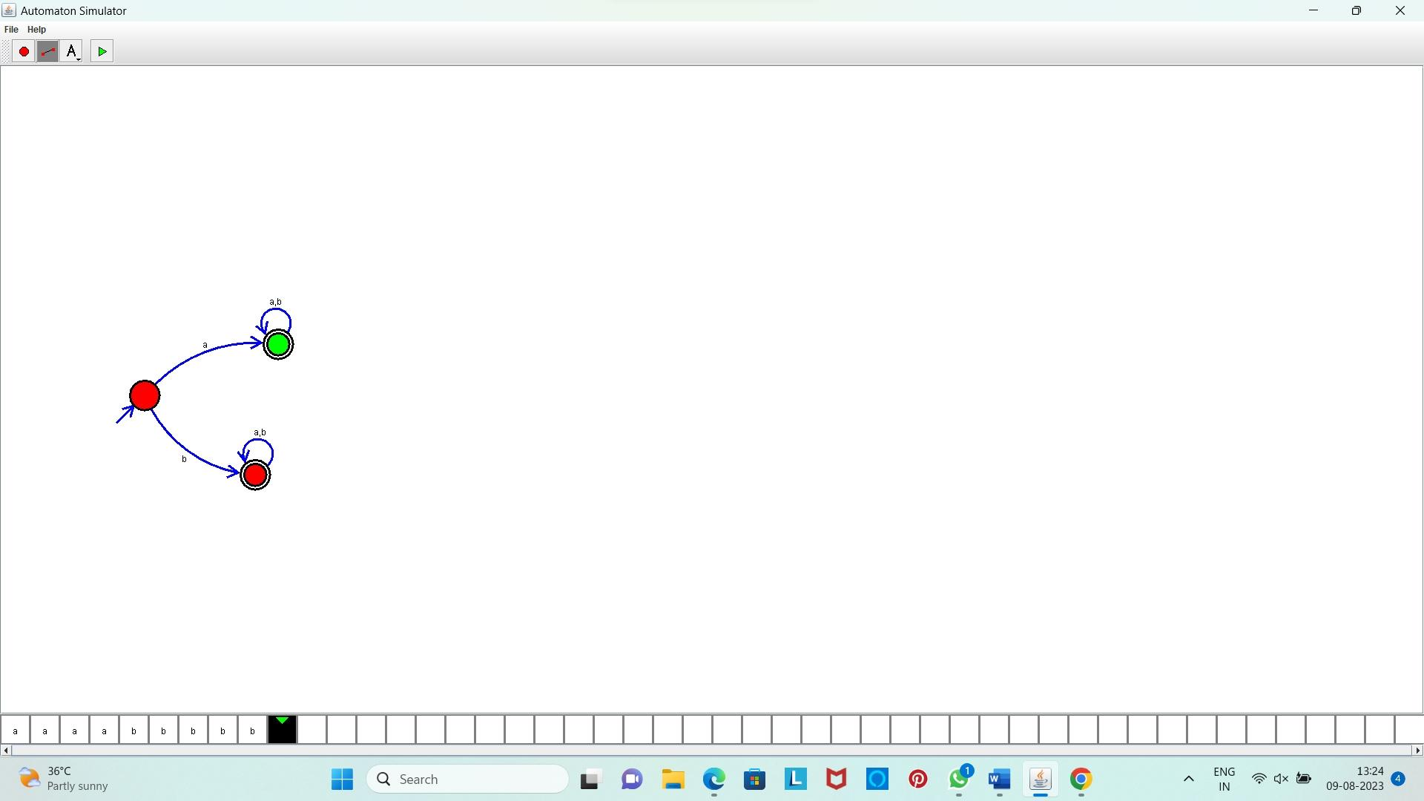

**Result:** Hence, we designed DFA using simulator to accept the string start with a or b over the set {a,b}